Jared Herdlevar, Jake Nasanov, Jeff Lytle, Zach Martinez, Nick Dantche

zztop@uw.edu

https://docs.google.com/document/d/1TqSmVIe-_8WelTzFtF7YeTzhHYqJEch4W9k208wb14s/edit

Deliverable 1

ZZ Top

Table of Contents

Summary 2

User Stories 3

Paper Prototypes 5

Figure 1: This is the landing page from which you can login or register for the contest 5

Figure 2: Clicking on login takes you to the login page 6

Figure 3: Clicking the register page takes you to the registration form 7

Figure 4: If an error occurred during login, registration, or submission an appropriate error will occur and ask the user to fix the issue 8

Figure 5: Above is the page that will allow contestants to submit their pictures 8

Figure 6: Clicking browse on the upload page will pop up a window to select a file to upload from your computer 9

Figure 7: Clicking submit on the upload page will make this page appear to let the user know that they successfully uploaded their drawing 10

Figure 8: This is a judge's view that enables them to score the drawings while the contestant remains anonymous tot the judge 11

# Summary

The three user stories that we chose with most priority is for users to submit their image electronically, users to be able to register before or during contest entry, and to be able to pass images to judges who can score them without any personal information attached. These user stories we chose we gave priority to because users need to have easy access to submit their images with as little effort as possible; the users need to have simple registration that anyone of any age can fill out (with parental supervision if necessary); judges need to have limited access to users information and be able to easily score users’ entries. We found these three user stories to be the most important because without them the library contest would not be possible.

For the paper prototype we have implemented the steps necessary to reach the goals of the three user stories we created and prioritized. There is a home page where users can find the “login” and “register” buttons. Upon entering the login page, users will be prompted for a username and password. Any incorrect information will result in an error. Thereafter, if the user is a contestant they will be sent to an upload form where they can upload any image from their local computer. If they are a judge then they will be sent to a page with a random contestant’s image and a score box where they will cycle through several contestants’ entries after each submission.

When a user needs to register, they will click on the link guiding them to the registration page. This is where their basic contact information will be implemented, and the terms and conditions will be accepted. If any field is insufficient or not filled in then an error message will occur, and prevent them from moving on until the necessary fields are filled in. After registering, they will be sent to the home page where they can log in.

# User Stories

1. As a library we would like contestants to submit their entries electronically
2. As a library we would like the user to be able to register before or during contest entry.
3. As a library we would like a system to pass entries to judges in a way that keep track of them but without personal info attached.
4. As a library we want to sponsor contest event to generate public support.
5. As a library supply prizes to generate interest.
6. As a library we want to use the trend of adult coloring books to generate interest in the library.
7. As a library we want a fun contest to spark interest in the library
8. As a library we want a contest that applies to all ages
9. As a library we want the contest program to be able to support at least a couple hundred entries.
10. As a library we would like to be able to select designs so that they can be used in advertising for the library.
11. As a library we would like winning contestants to receive adult coloring books as prizes.
12. As a library we want coloring designs to be downloadable so that contestant may color them
13. As a library we would like a simple registration system so that entries can be kept track of
14. As a library we would like the entries to be cut off at a certain date to give an end date to the contest
15. As a library we would like registration to be mandatory for contest entry.
16. As a library we would like to collect name age and contact info.
17. As a library we would like registration info policy to mirror current library cardholder policy.
18. As a library we would like to sort contestants by age for judging.
19. As a library we would like to only invite local community to participate.
20. As a library we would like to be able to assign groups of drawing to volunteer judges by age group.
21. As a library we would like some way to filter out inappropriate material from submissions.
22. As a library we would like a way to collect a way to collect the winning entries from the judges.
23. As a library we would like winning contestants to have a choice to release drawing for library use.

# Paper Prototypes

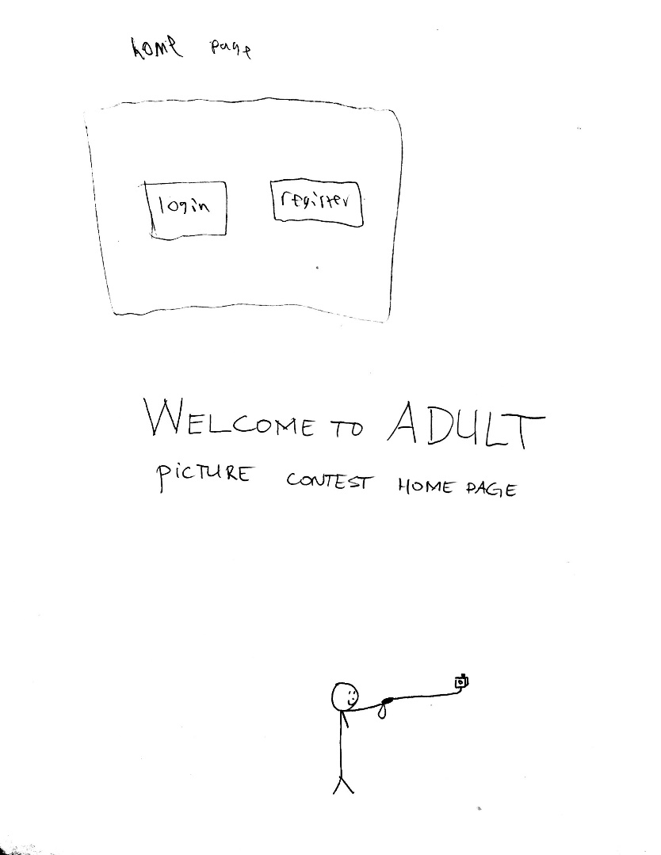

Figure : This is the landing page from which you can login or register for the contest

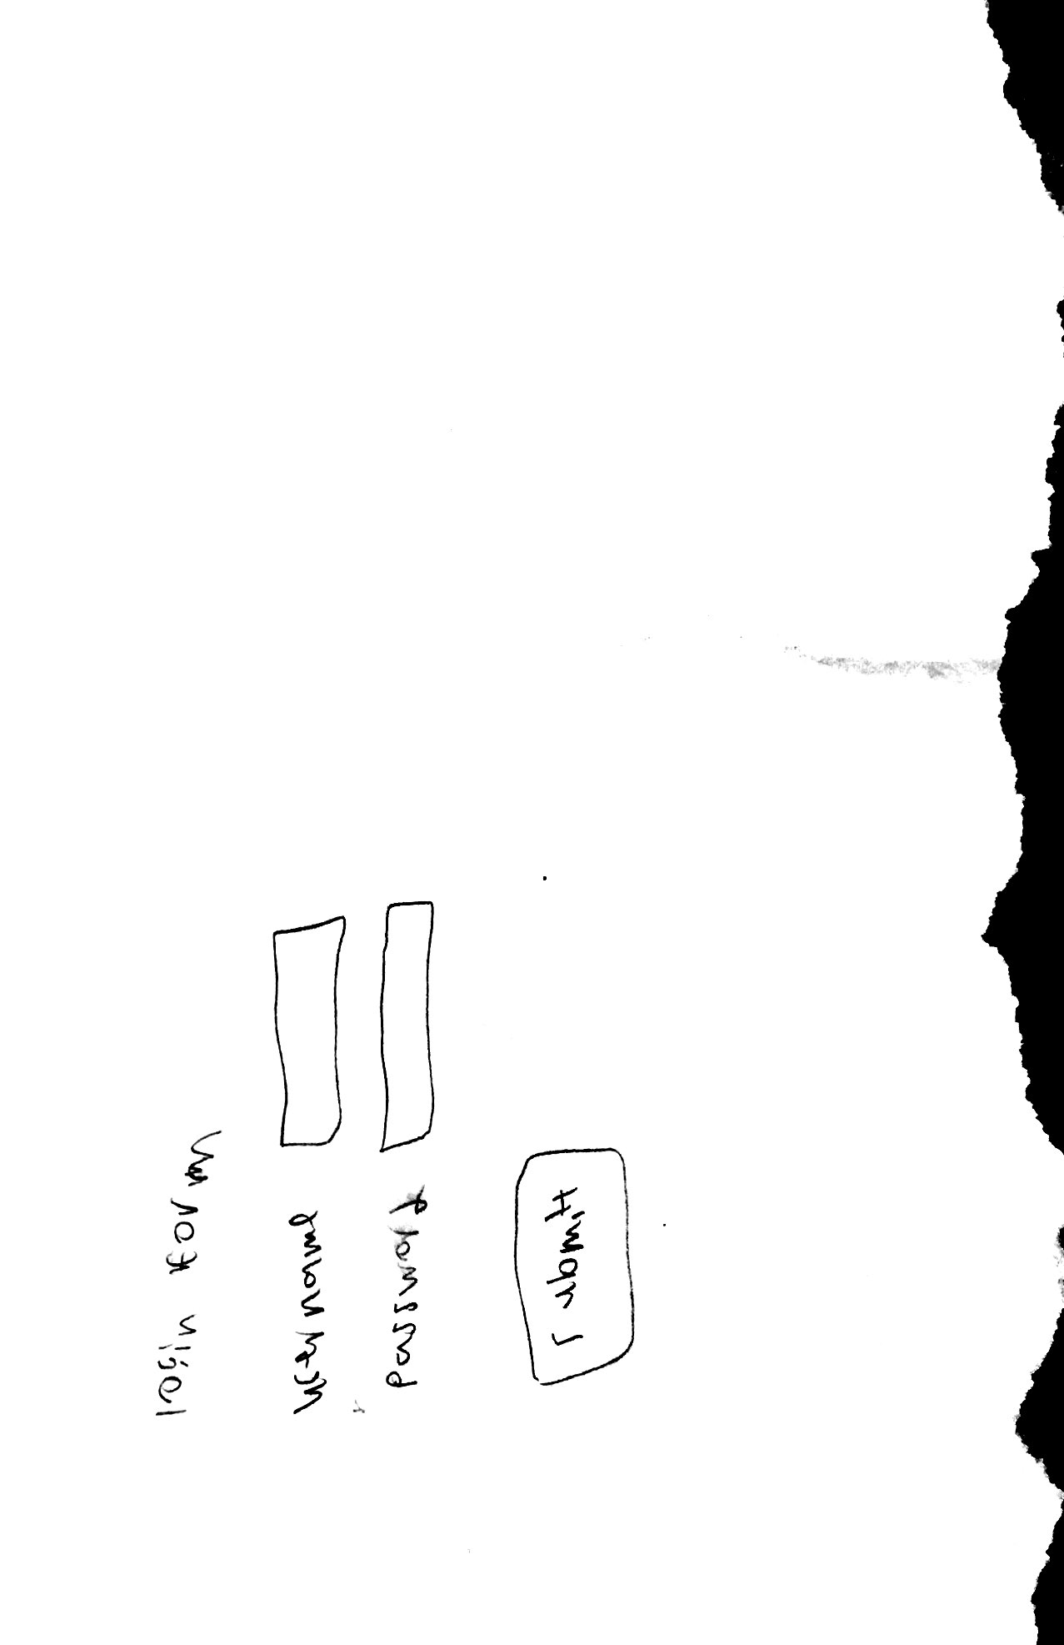

Figure : Clicking on login takes you to the login page

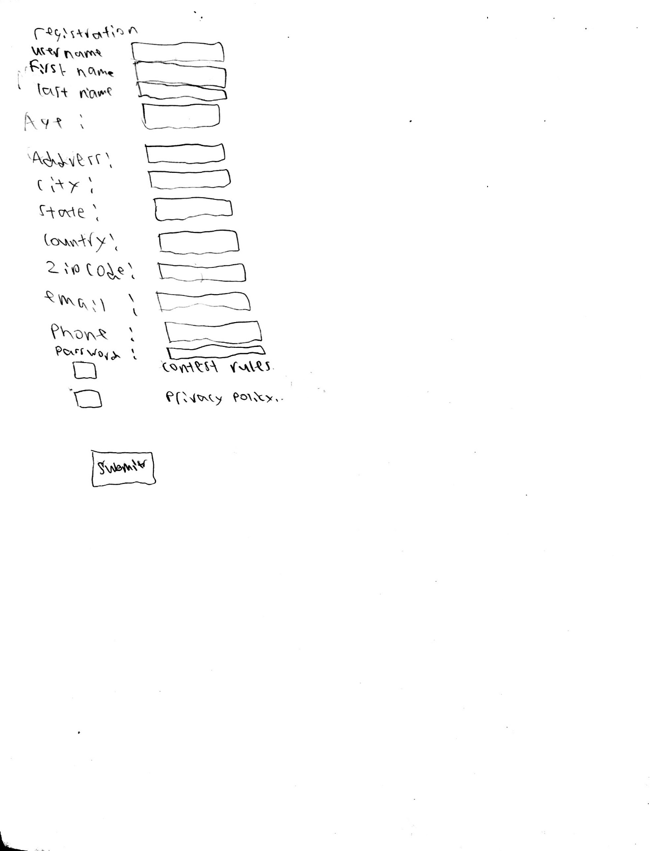

Figure : Clicking the register page takes you to the registration form

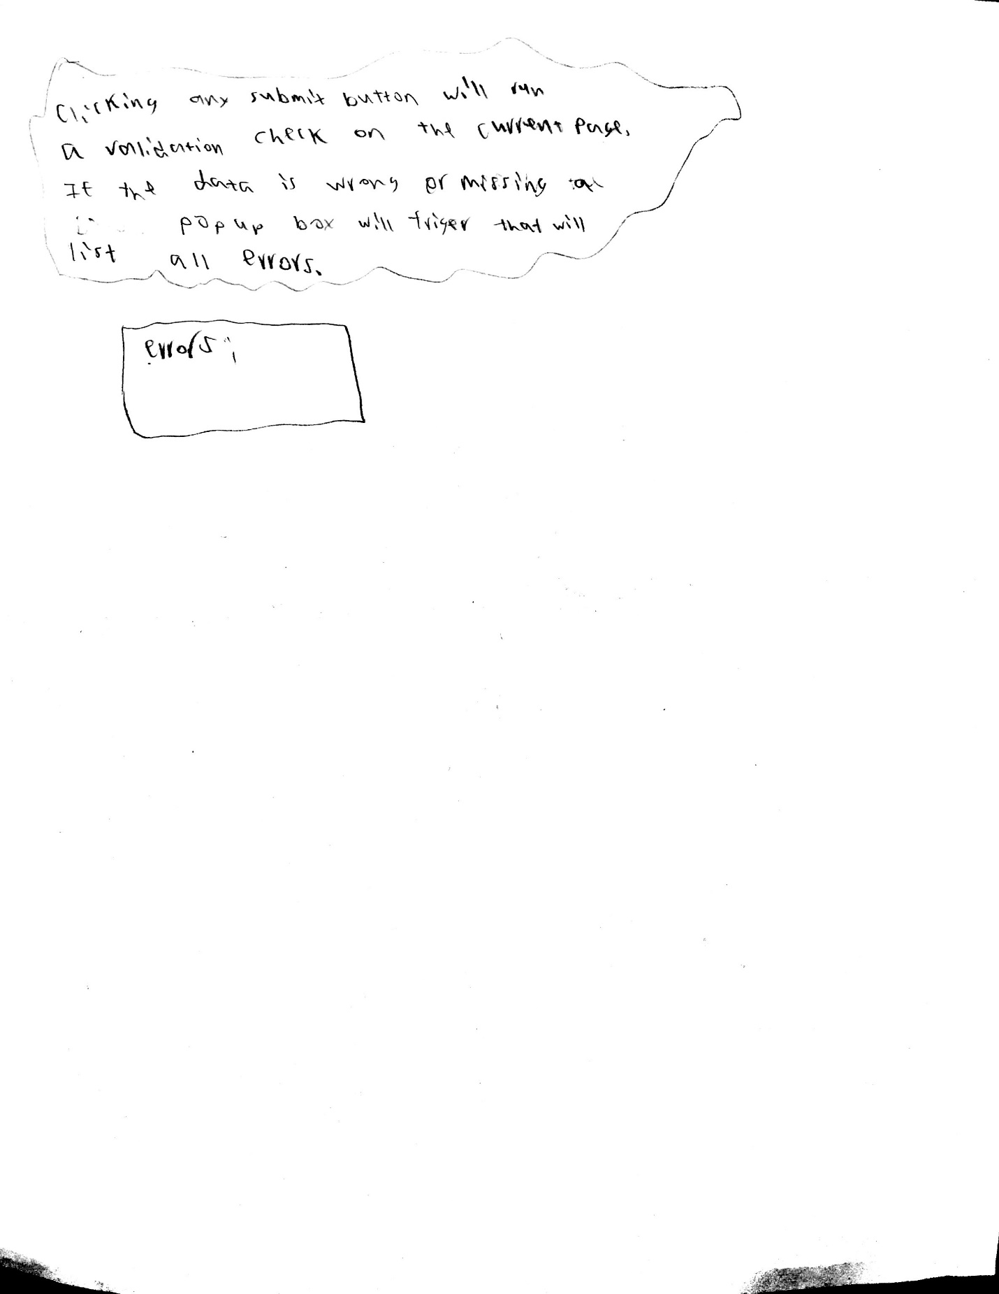

Figure : If an error occurred during login, registration, or submission an appropriate error will occur and ask the user to fix the issue

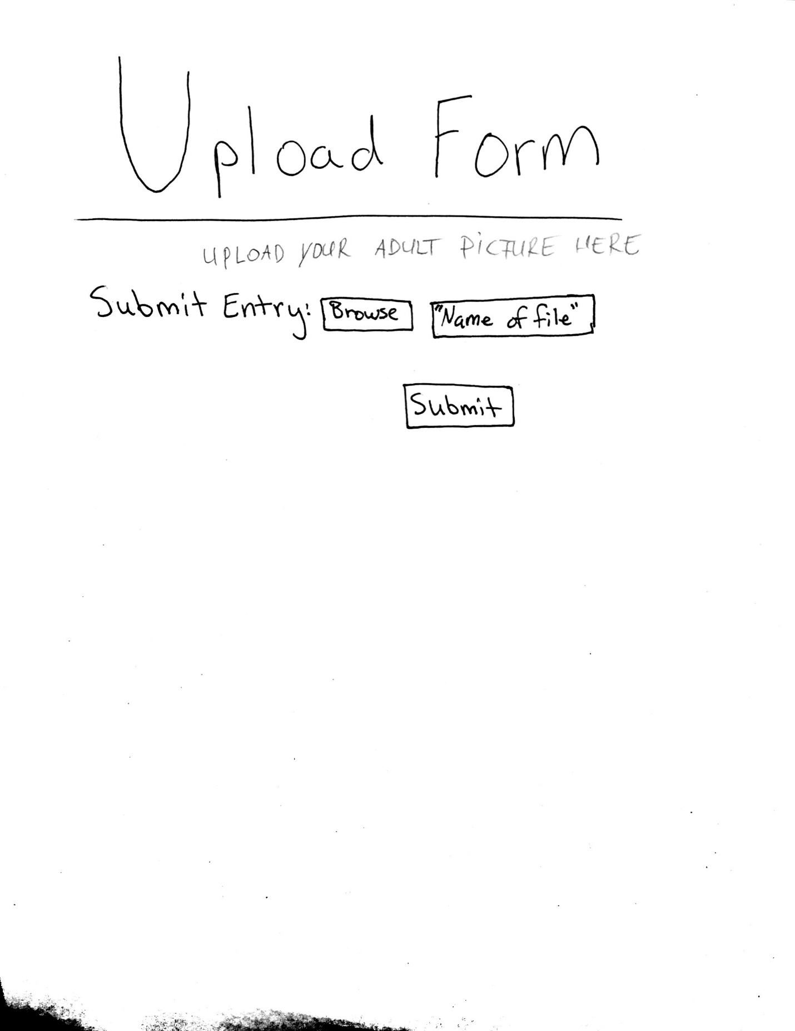

Figure : Above is the page that will allow contestants to submit their pictures

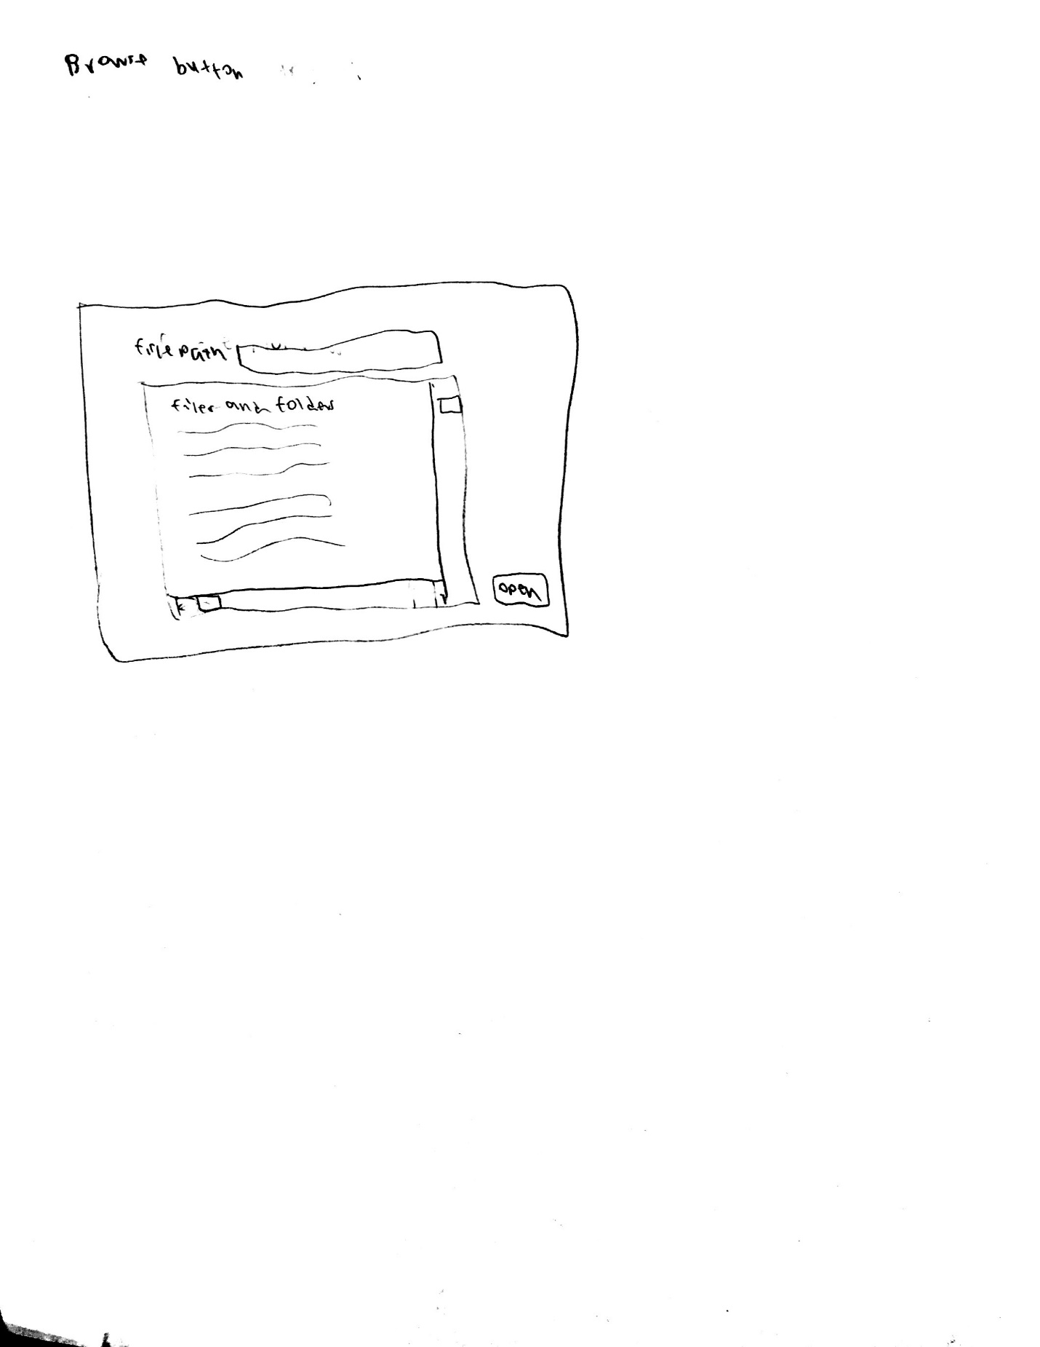

Figure : Clicking browse on the upload page will pop up a window to select a file to upload from your computer

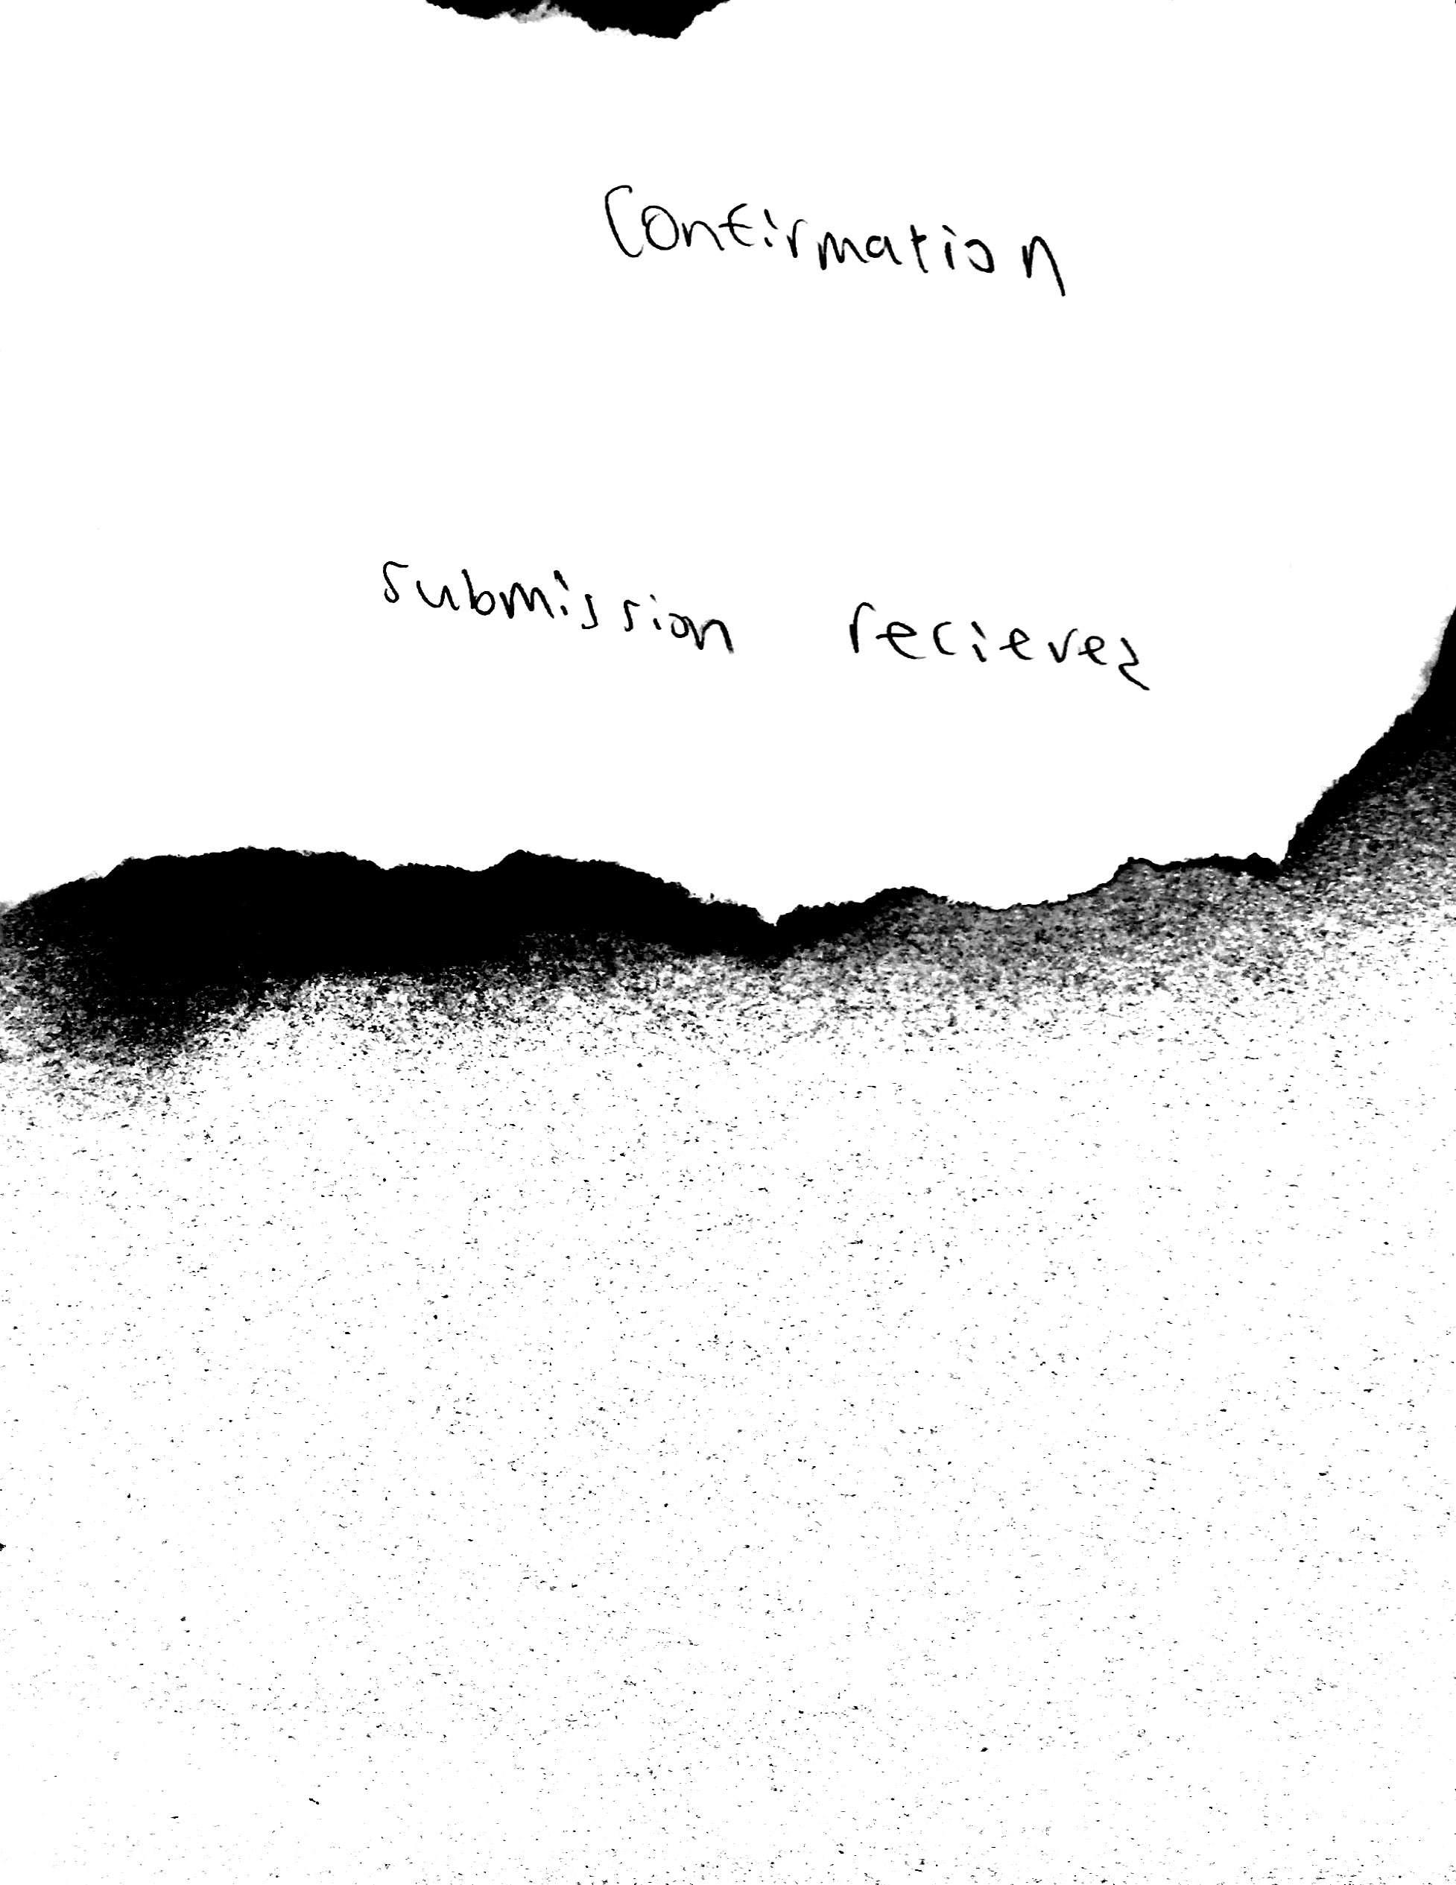

Figure : Clicking submit on the upload page will make this page appear to let the user know that they successfully uploaded their drawing

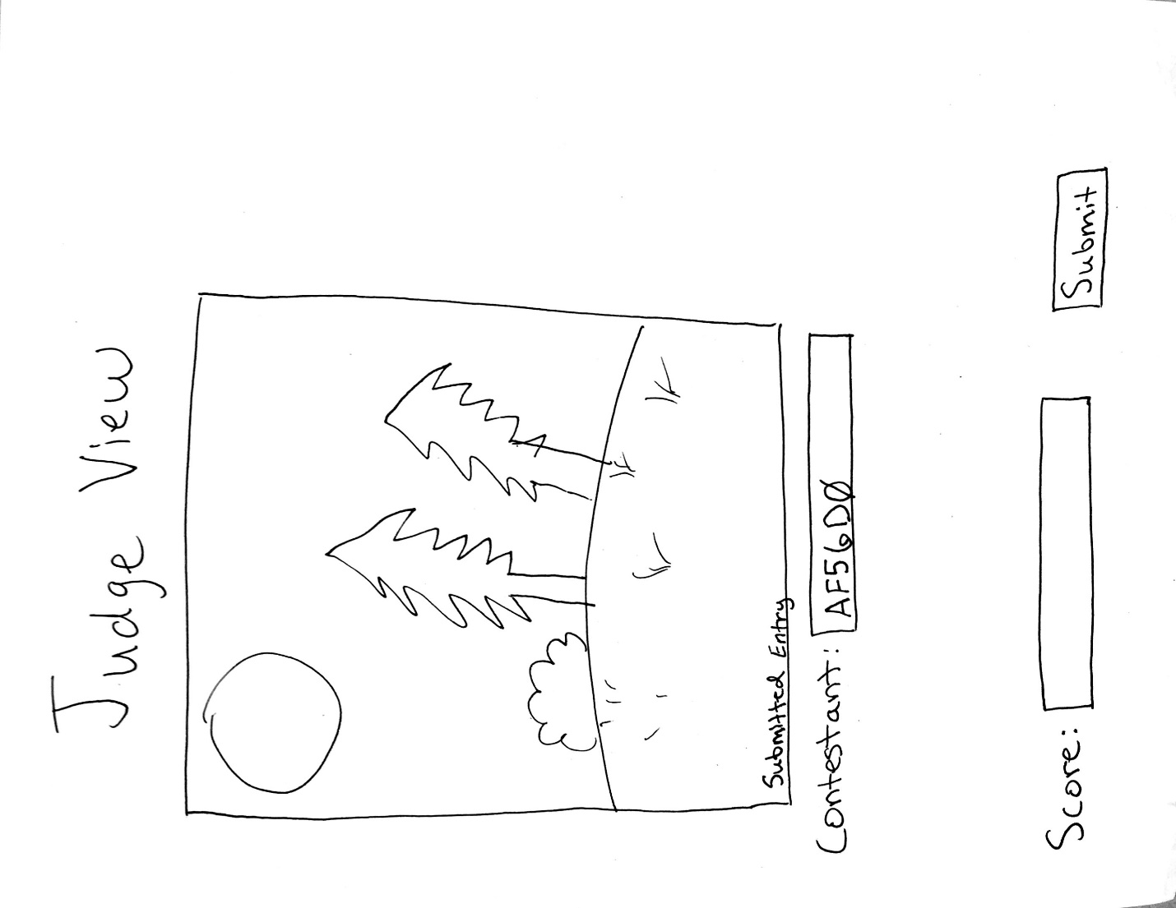

Figure : This is a judge's view that enables them to score the drawings while the contestant remains anonymous tot the judge